Are you a local dog owner?
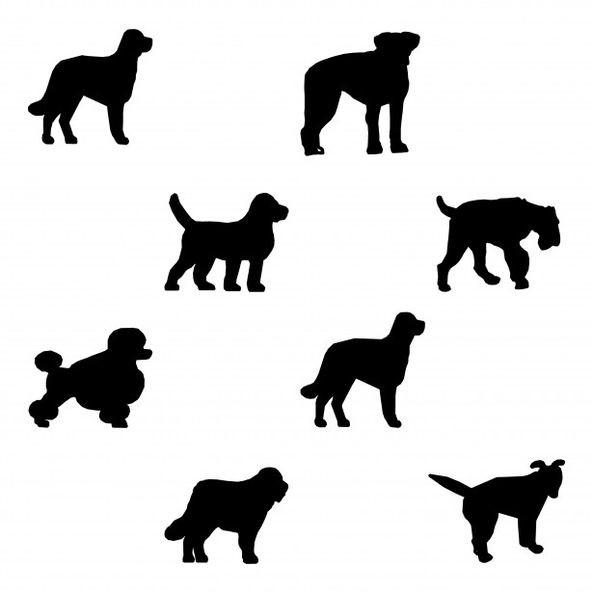

Unstone Parish Council need your views. The council are currently considering the purchase of a dog bin in Hundall and would like your views on whether one is required and if so where it should be sited.
Please e mail - clerk@unstone.org.uk with your views.
Thank you

